March 1, 2021

Dear Sir or Madam,

We are thrilled to be hosting St. Joan of Arc School’s Twelfth Annual Night of Knights Gala, on Saturday,
April 24, 2021. Traditionally, The Night of Knights is a delightful evening of dining, dancing, and donating held in the Hershey Country Club’s beautiful Keystone Ballroom. As the current pandemic has us optimistic we will be able to gather that evening in person, we are also planning to hold the auction portion of our evening virtually in case large gatherings will not be possible, and so those that cannot attend can still participate. All of the proceeds from this event will help with our ongoing mission of providing our children with a quality education in keeping with our Catholic traditions and values.

Established in 1927, St. Joan of Arc School provides Catholic education for well over three hundred students from the local Dauphin, Lebanon, and Lancaster County areas. As a private school, we receive very little outside funding and strongly depend on our own fundraising endeavors to help keep tuition at an affordable level for all students while still providing excellence in academics.

We hope you will consider making this event a success by supporting St. Joan of Arc School with a silent auction donation or advertisement that is specific to your business. A gift certificate or product would be great! St. Joan of Arc is a 501(c)(3) organization (EIN # 84-3619532 ) and all donations are tax deductible. An auction mobile bidding site will highlight your business’ contribution, and we will acknowledge your participation on the school’s website, which reaches over 300 families.

Please show your support by returning the Silent Auction Donor Form. If you would like to further discuss your donation or arrange pick up of an item, please contact Maria Angelo at 717-805-1908 or mangelo@stjoanhershey.org. If you are interested in becoming a sponsor or advertising on our auction mobile bidding site, please return the attached form. If you are interested in attending the event, please contact Deb Rizzotto at 717-533-2854 or drizzotto@stjoanhershey.org.

Sincerely,

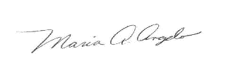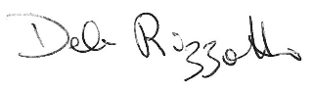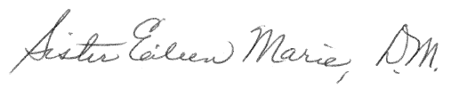
Maria Angelo Deb Rizzotto Sister Eileen Marie, D.M.
Silent Auction Coordinator Development Director Principal
Night of Knights Gala St. Joan of Arc School St. Joan of Arc School

P.S. The families of St. Joan of Arc School appreciate your generosity in this fundraising effort! We look forward to hearing from you and seeing you at our gala!

April 24, 2021 at 5:30pm at the Hershey Country Club’s Keystone Ballroom*

Silent Auction Donation
Please give a specific description of the item so that we may accurately describe it in the auction mobile bidding site. Please include any restrictions or expiration dates.

Estimated Value of item $_______._____
Contact name and phone #: ___________________________________________ (_____)_____-_______
Company Name ________________________________________________
Address: ________________________________________________
City, State, Zip: ________________________________________________

___Gift Certificate Enclosed ____Item to be picked up
___Item enclosed ____Item to be delivered on____/____/_____(date)
___Item not portable, my signature will suffice for buyer to receive my donation
________________________________ _________________
Signature Date

Advertisements
Premium digital ad: $100
Your ad will display prominently at the top of the mobile bidding auction site. It will be displayed more frequently as users cycle through different items and will allow the best opportunity for participants to recognize your contribution to our fundraising efforts. Option to include a URL link which would allow participants to click on your ad and be directed to your company's homepage.

Standard digital ad: $50
Your ad will display on various silent auction items and on the mobile bidding auction site main pages, but may cycle through less frequently than a premium ad.

Gala Sponsor
___Platinum Knight $1000 8 event tickets, premium ad, and logo or name on school website
___Silver Knight $600 4 event tickets, premium ad, and logo or name on school website
___Bronze Knight $300 2 event tickets, premium ad, and logo or name on school website

There will be recognition of sponsors in all communications for the event, including promotional materials, event signage, social media, and auction phone application.

