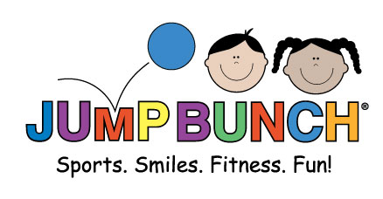
Who: JumpBunch Sports and fitness for kids; an international franchise and a leading mobile sports and fitness program for kids age 18 months up to 12 years old. More specifically Coach Andrew, our most experienced JumpBunch coach. Coach Andrew has been teaching JumpBunch to kids for over 6 years.
What: 6 week JumpBunch program with a new featured sport/activity each week, every class starts with warm up exercises to music and makes use of dynabands for growing muscles. JumpBunch provides all the safe age appropriate equipment needed, no extra costs.
Where: We come to you! Classes held right here at St. Joan of Arc no need to drive or carpool your child to their sports games and practices. Classes will be held outside weather permitting.
When: Thursdays from 2:45-3:15 pm, starting Sept 15th last class on Oct 20th.
Why: We provide structured fitness in a fun environment taught by a certified coach following lesson plans designed by experts in their field with the goal and focus of instilling a positive attitude towards healthy habits and exercise.
How: Register online at http://central-pa.jumpbunch.com/ and drop off $50 payment (checks made out to “JumpBunch”or cash) to the St. Joan of Arc office by Thursday Sept 15th.

Check out our website www.JumpBunch.com for more info or contact Andrew with any questions at 717-440-0211 or Apagel@Jumpbunch.com

