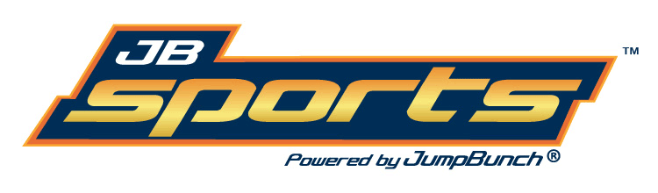
Who: JumpBunch Sports and fitness for kids; an international franchise and a leading mobile sports and fitness program for kids age 18 months up to 12 years old. More specifically Coach Ryan, one of our most experienced JumpBunch coaches. Coach Ryan has been teaching JumpBunch to kids for 4 years and has played multiple sports at the high school and collegiate levels.
What: 6 week JB Sports program with a new featured sport each week, lots of fun warm up games to engage even the non sports lovers, and JumpBunch provides all the safe age appropriate equipment needed, no extra costs.
Where: We come to you! Classes held right here at St. Joan of Arc no need to drive or carpool your child to their sports games and practices. Classes will be held in the gymnasium pickup at 4.
When: Thursdays from 3:15 pm -4 , starting Sept 15th last class on Oct 20th.
Why: We provide structured fitness in a fun environment taught by a certified coach following lesson plans designed by experts in their field with the goal and focus of instilling a positive attitude towards healthy habits and exercise.
How: Register your child online at http://central-pa.jumpbunch.com/ and drop off $50 payment (Cash or check payable to “JumpBunch” to St. Joan of Arc front office by Sept 15th.

Check out our website www.JumpBunch.com for more info or contact Andrew with any questions at 717-440-0211 or Apagel@Jumpbunch.com

